Search Engine Optimization:

One of the changes that I made to make my website more search friendly was that I added the Title tag in each of my websites which helps for the search engine what topic is on a specific page.



Another change that I made for my website was that I added the description meta tag in each of my pages so that it will give other search engine an overall synopsis of what I a talking about in the page.



A Sitemap was also added into the website which will help other users to easily navigate and to also for the search engines to find any new pages on my website.

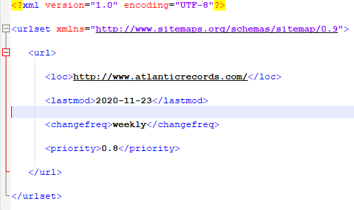

Also another change I made for the website was adding the alt attribute inside the image tags which makes any alternative text for the picture.



The last change that I made was making the website more mobile friendly as this would be a very important change as it can bring more attraction to the website as more people these days are more often on their mobile phones rather than on a laptop.

This was done by adding the media queries into the CSS of the page as it will classify different models for different browser sizes.

